Network task

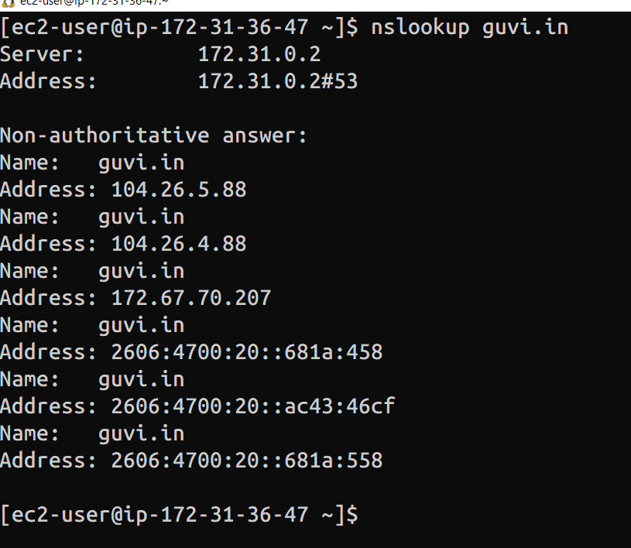

Cpu usage – top com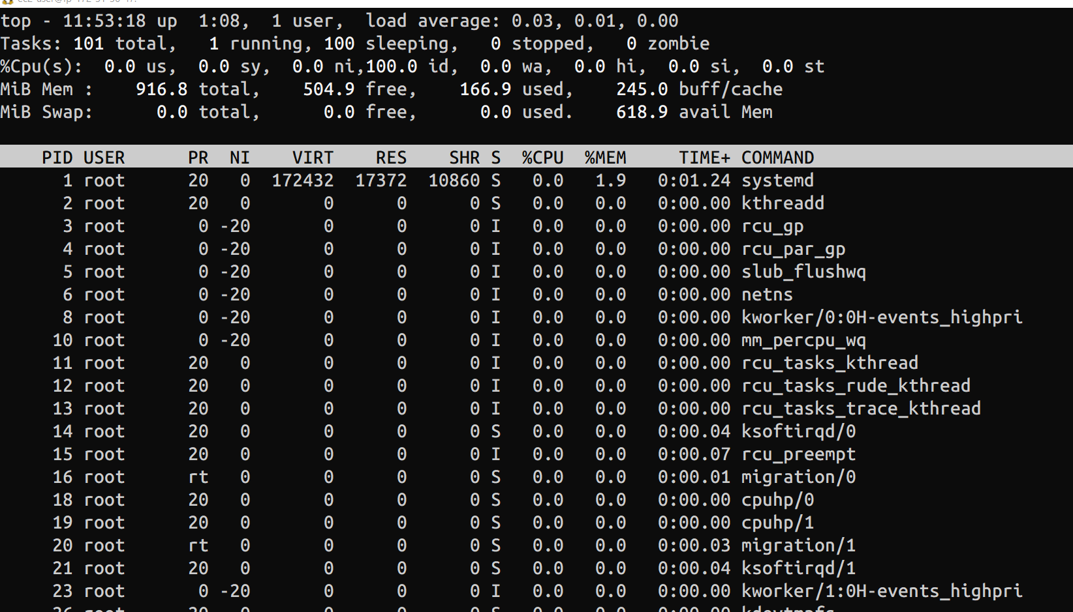

Test connectivity between two nodes
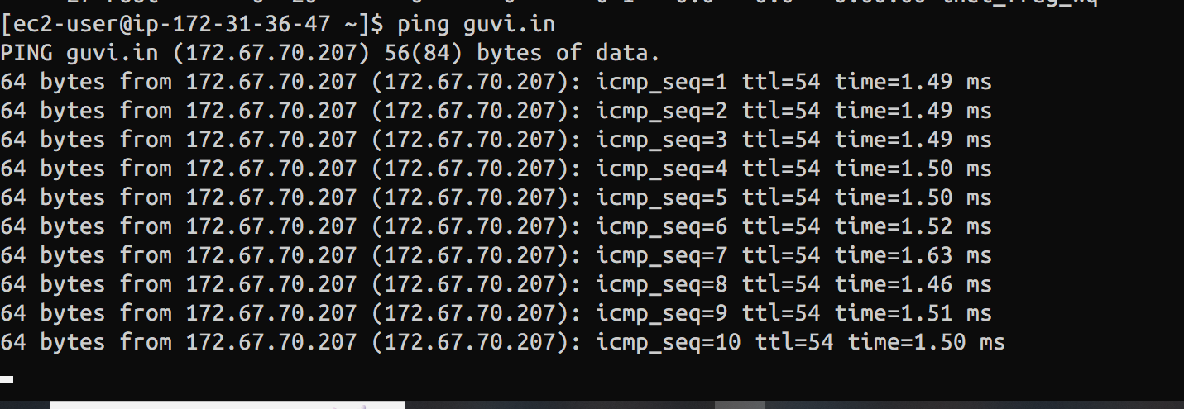

- I have deployed an application in guvi.com:9000, and logs show my app is running, but I’m unable to view the page. Check whether my port is open or not ?

